10-5-23 notes
Merging and Data Cleaning
Goals:
By the end of this lesson, you will be able to:
- Slice data by using the cut() method.
- Create new values based on a series of bins.
- Fix common Python and Pandas bugs in Jupyter Notebook.

Joining/merging:

Good websites to review types of joins:
https://www.shanelynn.ie/merge-join-dataframes-python-pandas-index-1
https://stackoverflow.com/questions/38549/what-is-the-difference-between-inner-join-and-outer-join

Pandas uses only inner, outer, left and right joins.
Default merge is an inner join (only pulls records that have a common item in both tables)

Oter join pulls all records, whether or not they’re in the other table or not.
Merging DataFrames: Right and Left Joins:
These joins protect the data contained within one DataFrame, like an outer join does, while also dropping the rows with null data from the other DataFrame. (imagine Relational DB diagrams in Access book, where there’s two tables next to them with an arrow going L to R or vice versa)
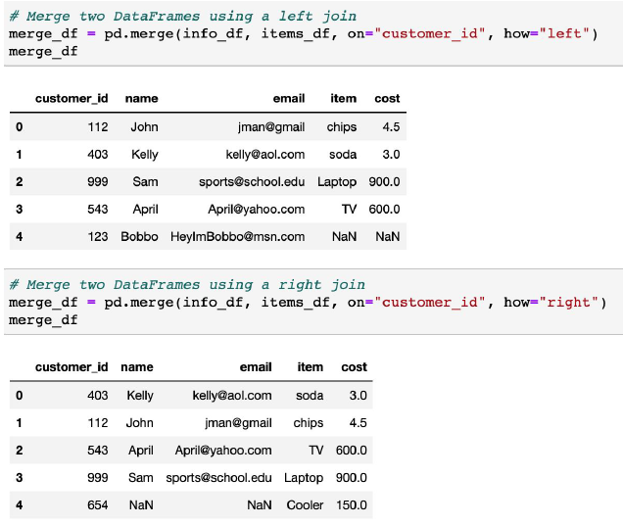

POWER FLICKERED AT 6:55PM. REJOINED CLASS AT 7:02PM

Binning:
Binning is the act of putting records in metaphysical bins based on similar values.
^ 6 bins are created. First bin is 0-59.9%, Second bin is 60-69.9%
^group_names is the list of labels. Number of labels must always be one less than the number of groups

Mapping:
You can map a format to a certain column.
Bug fixing/Debugging:
The first step: Keep calm.
Pandas is not known for returning clearly understandable error text

The second step: Figure out what the bug is and where it’s located.
KeyError and ValueError are common starting points for figuring out
Sometimes a number will be stored as an object, and can cause an error saying that you can’t do a numerical calculation or function on it.

“If the error text isn’t entirely clear, it can be helpful to print out variables/columns to the console to
uncover the bug’s location. For example, printing out the Percentage series lets the programmer
know that the data type of this Series is an object and not a float.”

Terminal will display the full details for the first error it encounters.

The third step: Research the error online to find solutions

Intro to bug fixing solution:
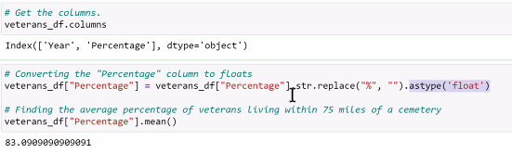

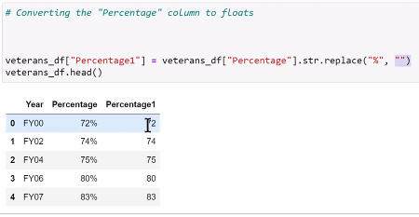
Output above is BEFORE Manish ran the code above to replace any percentage signs.
After this it’ll be fine to be changed to a numeric form, and have calculations performed on it (like Average, Min, Max, etc…)

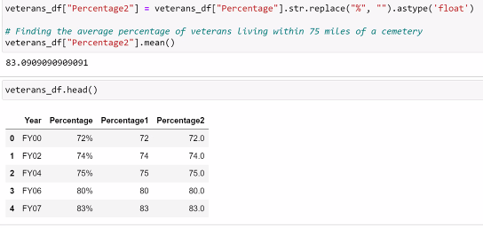

Bugfixing Bonanza!!!

When dividing, use / \
Parentheses are your friends. It forces proper order.

Sometimes errors appear over and over again. Fix it once and for all the first time you run into it.
In this activity, it was renaming the columns.

Last cell of activity-
Check the contents of the items you’re trying to merge to verify that they share values.
It had a Join, but needs a merge too. (see first code snippet in the presentation pdf).
REVIEW 9:33pm-9:37pm Manish will be reviewing why it needs both .join and .merge.
.merge and .join functions work differently.

